Statement of Significance Tower Roof and Weathervane

All Saints Church, Kempston (Grade I)

Part 1. The church and its environment.

The church stands near the River Ouse in a secluded spot about 1 mile from the centre of urban Kempston Town. It seems remote until you realize that it is central to the whole parish and its many rural hamlets or ’ends’. The parish is approx. 6 miles long with an average width of 3 miles.
There is evidence of an Anglo Saxon church on the site, and the present church was built on the land where this Anglo Saxon church stood. Commissioned by the Countess Judith, a niece of William I, it was built in 1099. Traces of the small original Anglo-Saxon church can still be discerned in the exterior stonework. The north and south aisles were added to the church during the 13th century, but further major rebuilding took place in the 15th century: the chancel was extended to its present length; the tower was raised in height to accommodate the bells; the clerestory was added to the nave; the large windows were created, so flooding the church with light for the first time; also, a porch with a room above was built over the south door. This great reconstruction left the church layout much as it is today. The only addition, in 1823, being a mausoleum on the north side of the chancel for the Long family, which now serves as the Vicars vestry.

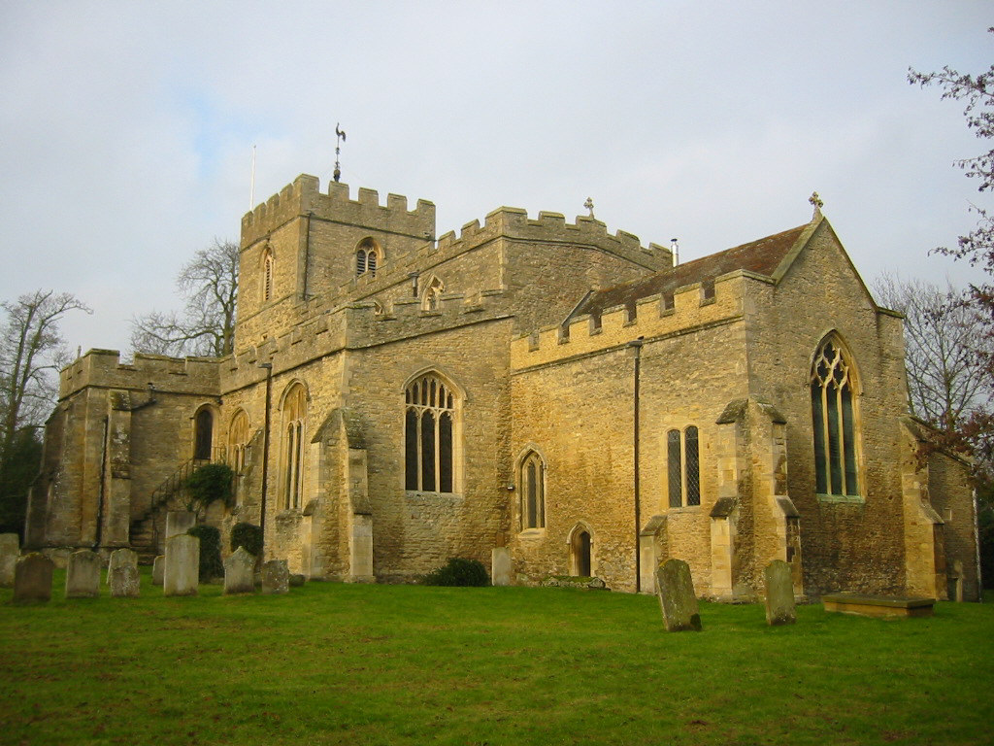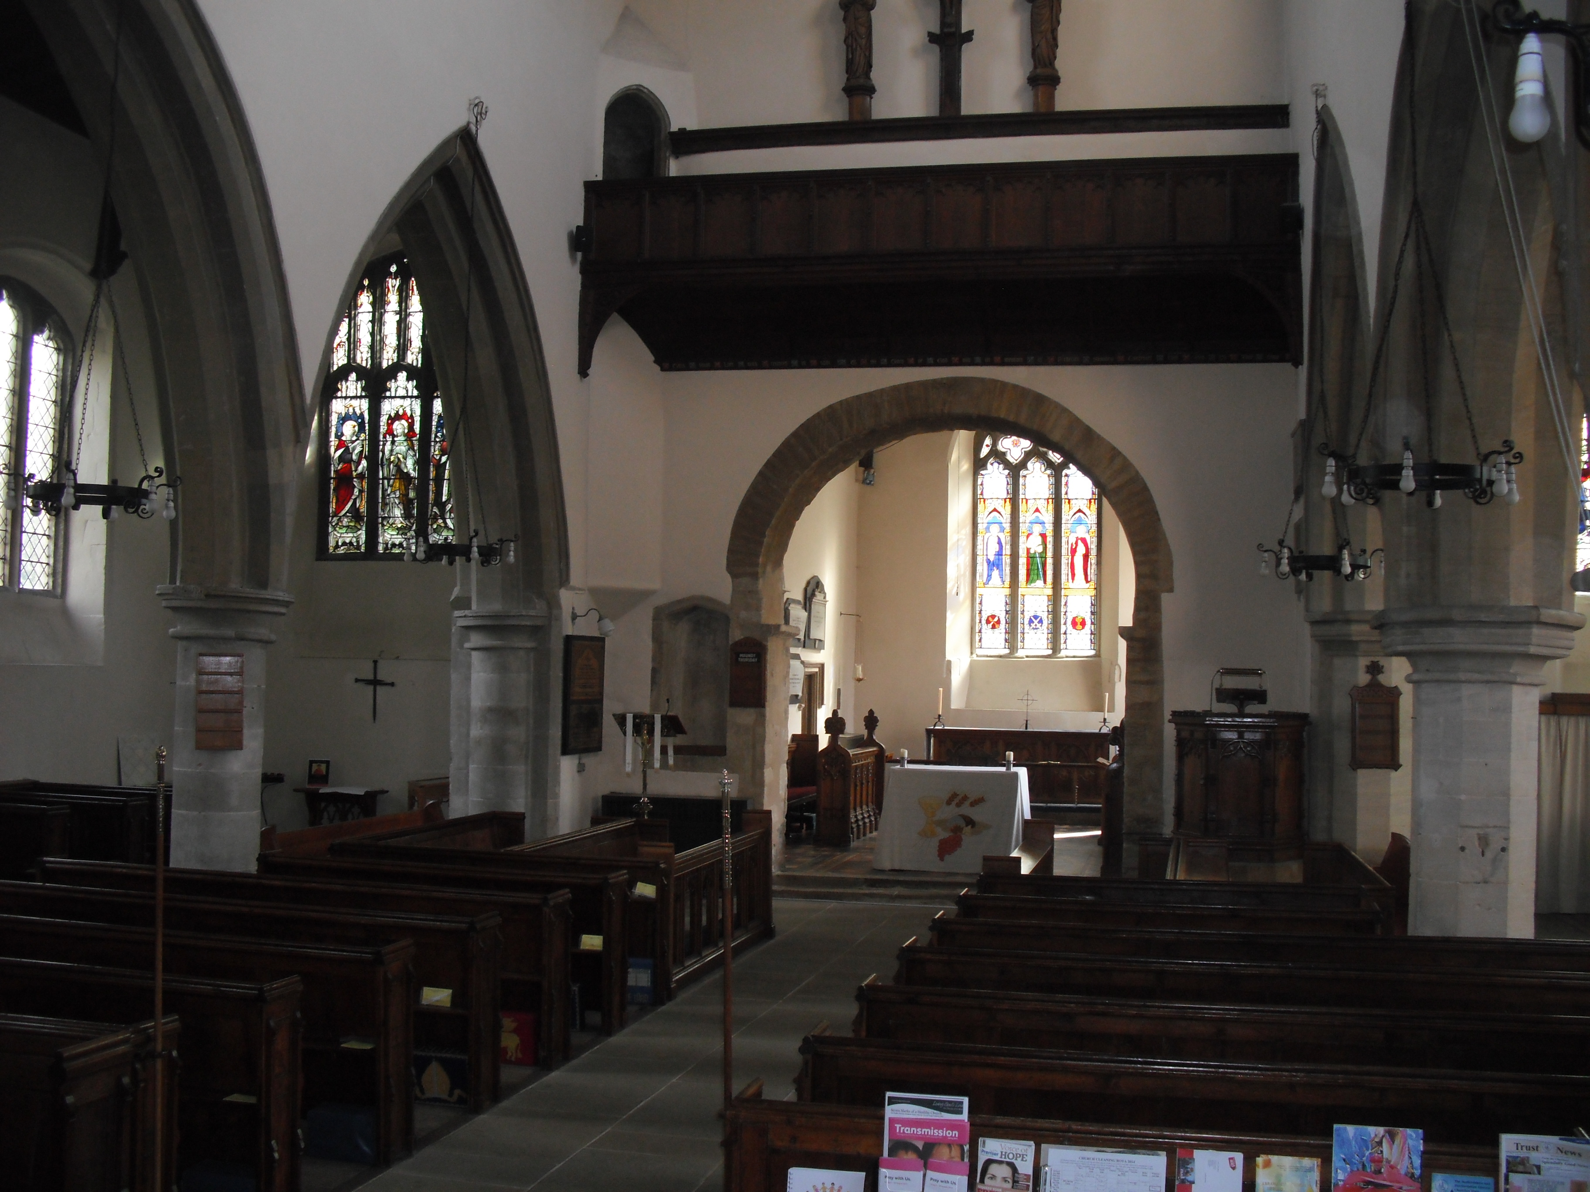

The nave with north and south aisles, is approx 24 x 24 metres, the chancel is approx 14 metres long x 8 metres wide, there is a 3 storey west tower incorporating 10 bells, a south porch with priest room over and the Vicars vestry on the north side of the chancel. The church is built of stone, the tower, nave and porch have a wooden roof covered in lead. The gabled chancel roof is tiled.
The walls of the tower are 5 feet thick at the base. As you look at the tower from the outside, on the left (south side) is a tiny window which shows how small the original windows were. The lintel of this window is in fact Saxon in style.
The 14th Century stone font, with beautiful carvings of the Saints and the Apostles around it sides, was mutilated during the Commonwealth period by the soldiers and agents of Oliver Cromwell. One can still see the marks of the chisels used to wreak the destruction. The font was moved to its present position in 1901. The ornate, octagonal oak cover dates from 1901.
The Norman arch at the entrance to the chancel probably replaced an earlier Anglo-Saxon structure. It is decorated with a nail head moulding. This ran inside the whole church until the side aisles were added in the 13th century.
In the wall of the sanctuary, to the right of the high altar, is a double piscina, having two arches with a central supporting shaft, a feature not often seen, especially in a country church.
The dates the stained glass windows were installed are;- NE window in 1912, the SE window in 1923 and the Chancel window in 1852.
The church was flooded in 1823, and as a result, in 1824 the floor was raised by a foot, subsequently, in 1901, it was lowered back to its original height.
The history books state that after the flood of 1823 box pews were introduced. These were altered twice in the 19th century, and then in 1901 they were taken out, the doors removed, and they were then reconstructed with sloping backs as you see them now.
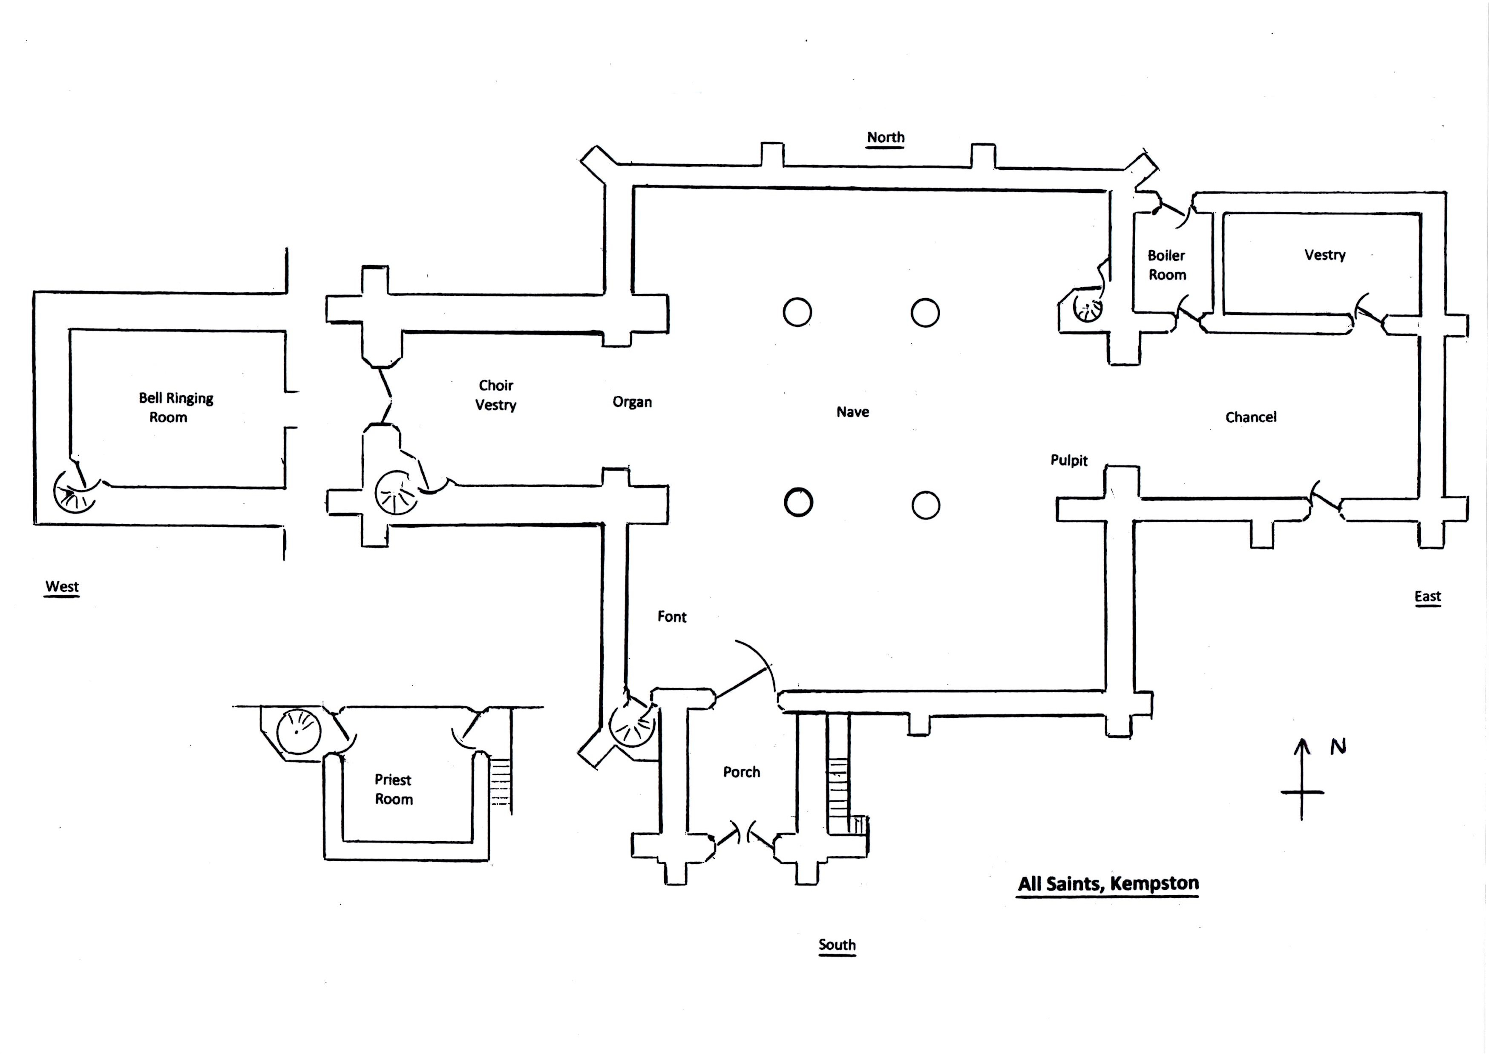
If you go outside to the east end of the church and look back, you can make out the line of the ancient roof in the masonry, and a window, also of Saxon design, in the gable end above the Chancel arch. High up on either side of the north and south chancel walls, traces of two narrow Norman windows can be seen.
Carved into the left hand buttress at the porch entrance is a circle of small holes, with a larger central hole. This is known as a Mass Dial and the Priest would move a pointer like a hand of a clock to indicate the time of the next Mass.
As the population of Kempston grew, so the churchyard had to be extended. The extent of the original churchyard can be seen as you go down the path to the west gates. The first pair of yew bushes mark the position of the first gate. When the path was dug up to install the lighting, the stone footings of this gate were revealed. The churchyard was ‘closed’ in 1878.

Part 2. The significance of the area affected by the proposal. The Tower Roof.

The proposal is to remove the current Weathervane Post and replace it with a new Weathervane Post. To also carry out works to the Tower Roof where the Weathervane Post is removed.

The Tower
The west Tower dates from the late 11th century, it was raised to its present height in the 15th Century to accommodate the Bells.
A building of stone, in the Norman and Decorated styles, a western tower of Norman date, originally containing 6 bells, two of which were cast in 1603 and 1619: in 1893 three of these were recast and a treble added by Walter G. H. Harter esq. of The Bury.
The Weathervane
There would probably have been a weathercock, or vane, on the tower from earliest times. Our present Weathercock is quite new, the Log Book records that Reg Anstey replaced an earlier 1770’s one in the 1990’s.
There's no mention in the Log Book of any repairs to the Oak Weathervane Post at the time when Reg Anstey replaced the Weathercock.

The Bells
The tower contains a ‘Ring’ of ten bells (dated 1893 to 1980), plus a small calling bell (1869) and two old bells, (1603 and 1633).
The ten bells are fitted with cast iron headstocks, fixed steel gudgeons, self-aligning ball bearings, traditional wheels (re-using the old wheel centres), traditional stays and sliders, and clappers with independent crown staples.
In 2019 two Caldey Island / Prinknash Abbey bells of 1910 (the nos.7 and tenor) replaced the original bells of 1603 and 1633. The two seventeenth century bells, were rehung separately in a steel framework above the ‘Ring’ as chiming bells. They are fitted with electro-mechanical chiming hammers.
As well as the ringing bells, the tower also contains a small Sanctus bell (1869) obtained from the old Elstow School buildings on Ampthill Road, Bedford in 1964.

The PCC of All Saints Kempston believe that replacing the Weathervane Post will have no impact on the significance of the Tower.

